IDM project design phase
Research
For this stage of the project I researched many news sites and cataloged the ones I liked. In the end I decided to go for a gaming news website as I’m not very interested in sports or politics.
I searched for gamming news sites and kept the best 3 for reference, polygon, the verge and IGN videogames.
Likes
- IGN
Most of the sites I visited had similar layouts and navigation styles with my favorite of them being IGN. IGN had a very pleasing home page with a simple yet effective nav bar and sign in button on the top right and a big logo on the top left. Below that was a giant background picture with a link to the main article of the day. This design seems simple but it lets the user navigate his/her way through the website easily, and it allows for the site to captivate the users attention by displaying beautiful artwork right in front of them in the form of the main article of the day section. I especially like the colour choice, it was dark grey and white with red buttons here and there to add a bit of colour, it was simplistic yet very effective and not too overwhelming.
- Polygon
Polygons home page was what I could only describe as advertiser friendly, with a logo and nav bar on the top right and a search bar with media links to the left. Right below that were 2 big add pictures and a line of adds ran down the right hand side of the webpage with only one article to the left/middle of the page. Navigation was quite easy with that big nav bar on the top left of the page, I especially liked the media links to the right of the page, they were quite useful and filled the empty space well.

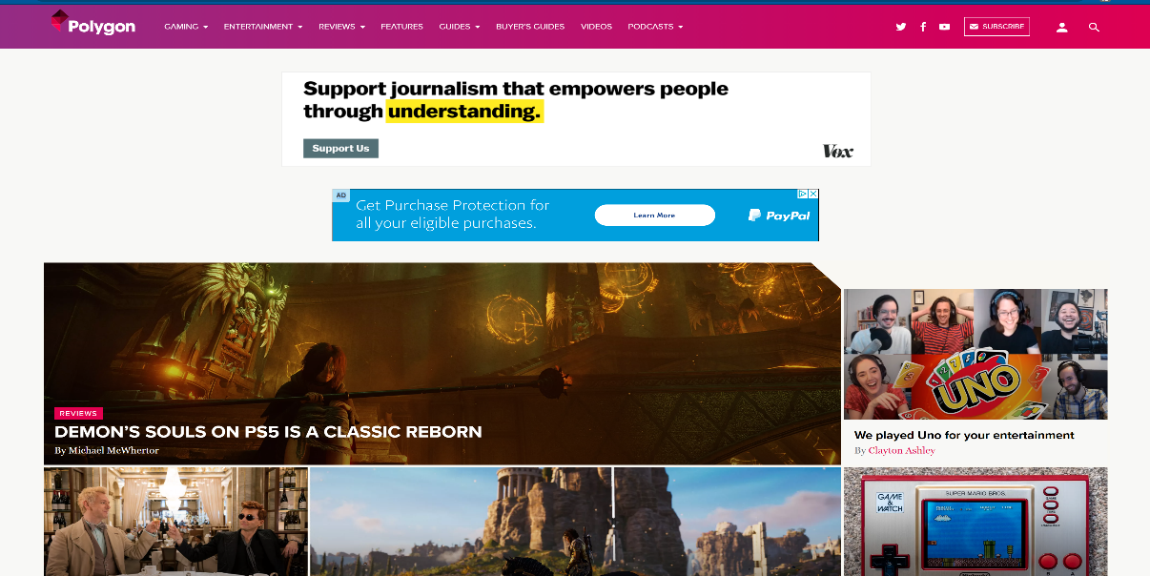

- The Verge
The Verge’s design was very symmetrical, everything was in the middle from the huge logo to the nav bar below it, this was quite pleasing to eye. Below that were 2 adds and 3 articles side my side perfectly aligned with the nav bar. I especially liked the coloured borders around the articles and the colour choices in general. The page had a black and white theme with red and orange borderlines that surrounded some of the articles, these border lines were blended together so well that it gave the illusion of movement when I scrolled down the page.

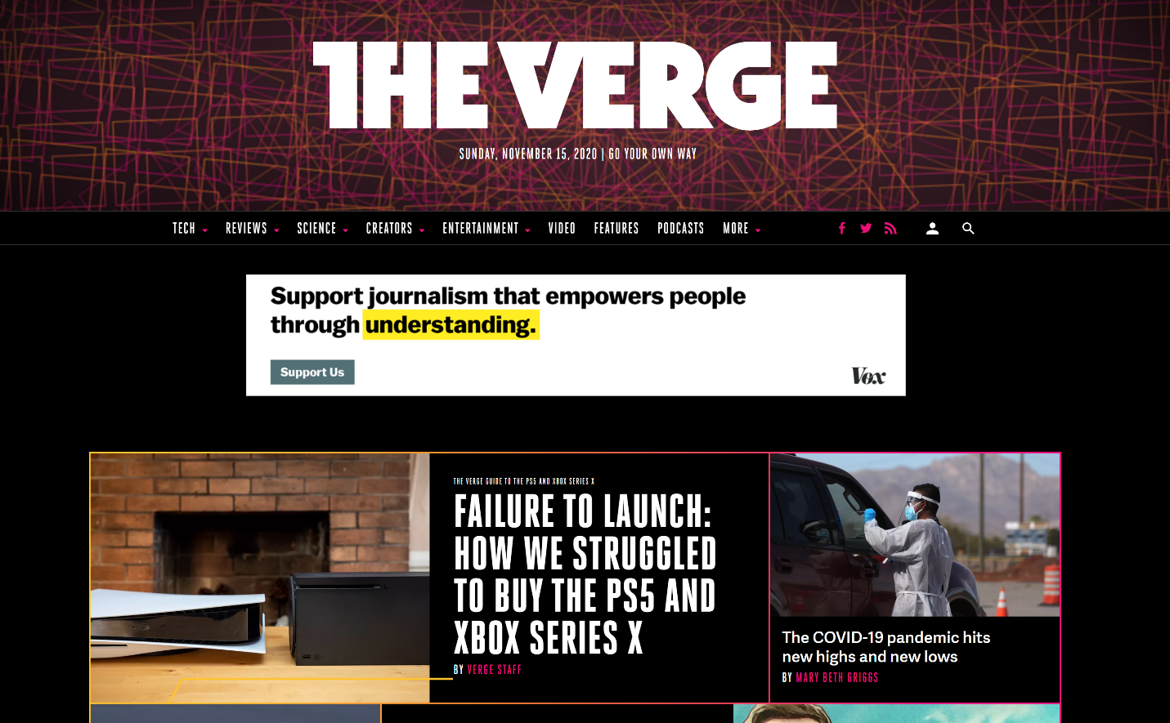

Dislikes
- IGN
IGN’s home page seemed perfect to me at first, the design wasn’t cluttered or too simplistic, it struck a balance. However I realized that it had virtually no adds, in fact I only saw 2 adds in the whole page, this would be fine with me as I don’t really like adds anyway however the website im supposed to create must include adds.
- Polygon
Polygon’s home page had the complete opposite problem to IGN, it was littered with adds which I found a bit annoying, the page also seemed to lack structure as articles were placed along side adds without anything to tell them apart, I actually clicked on an add thinking it was an article. The coloure choices were also a bit messy in my opinion. The page had a white background with red accents in the form of red highlighted text, however there were so many colourful adds that the page looked messy with every colour under the sun. 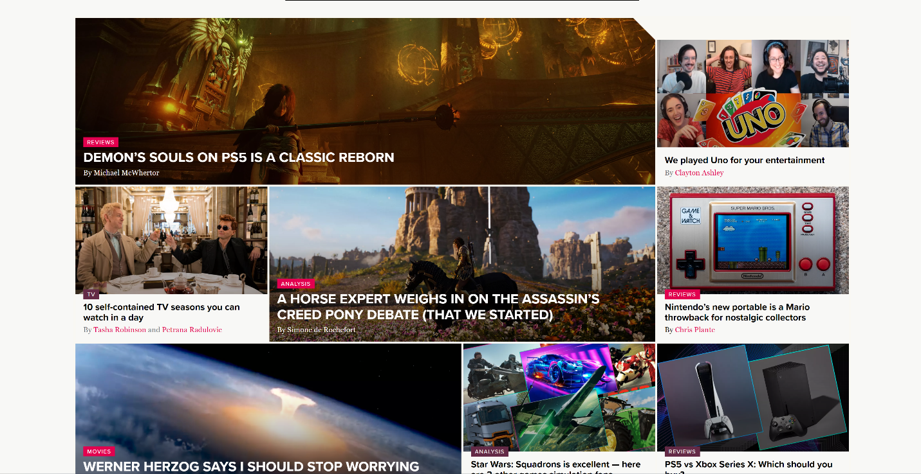

- The Verge
The Verge’s webpage was nice and symmetrical however the colour scheme was a bit disappointing. The colour scheme was nice at first with a black background and articles highlighted with red and orange borders, however after scrolling down a little the background goes white and the borders disappear leaving you with boring articles and colourfull adds thrown everywhere defeating the purpose of the symmetrical design.
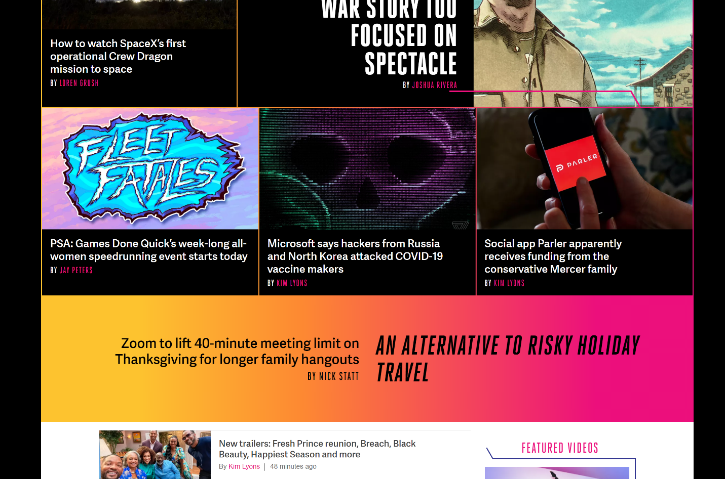
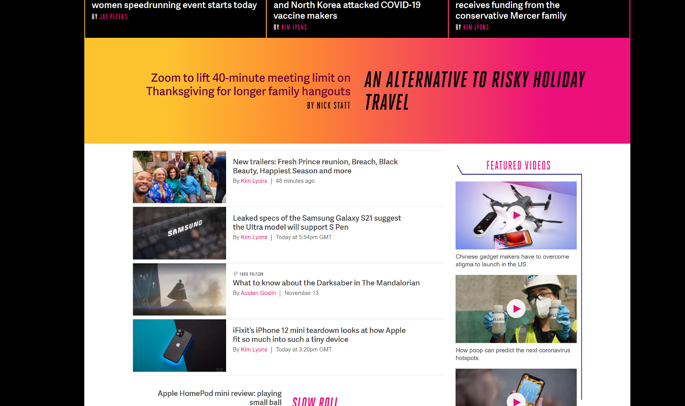
Personas
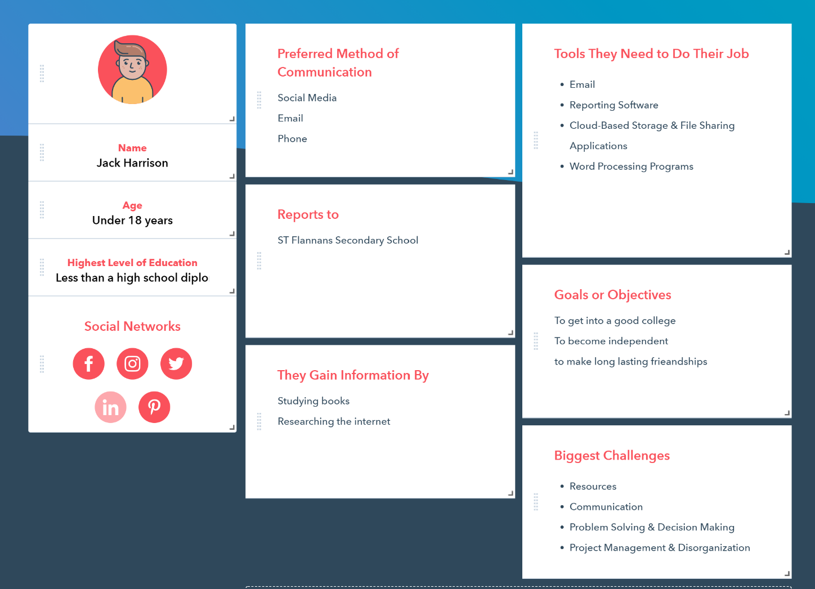
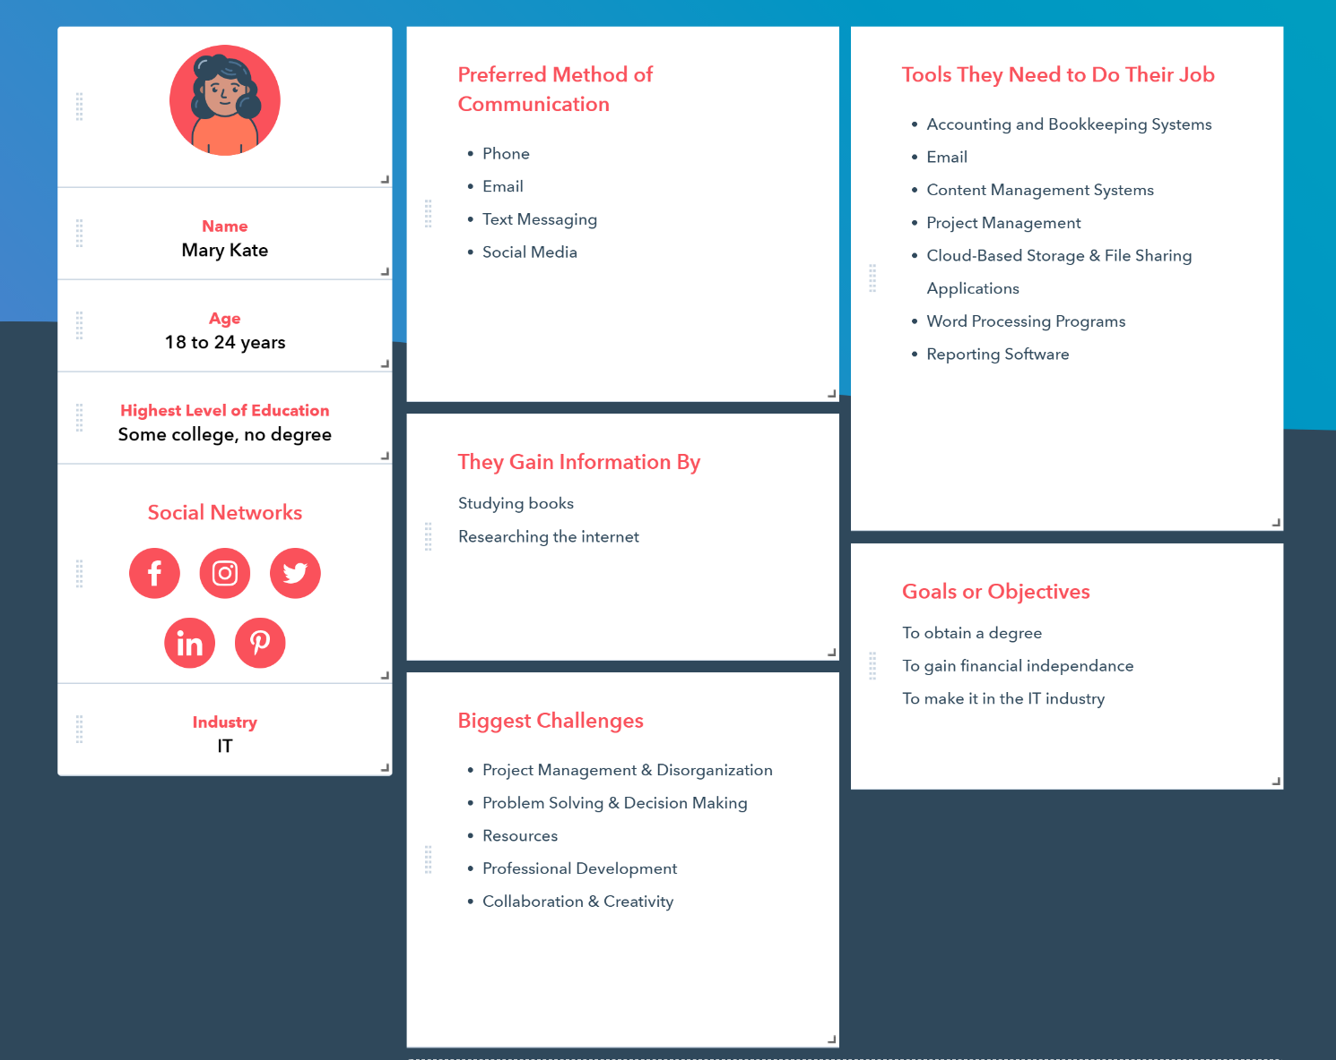
My Design
Home page desktop
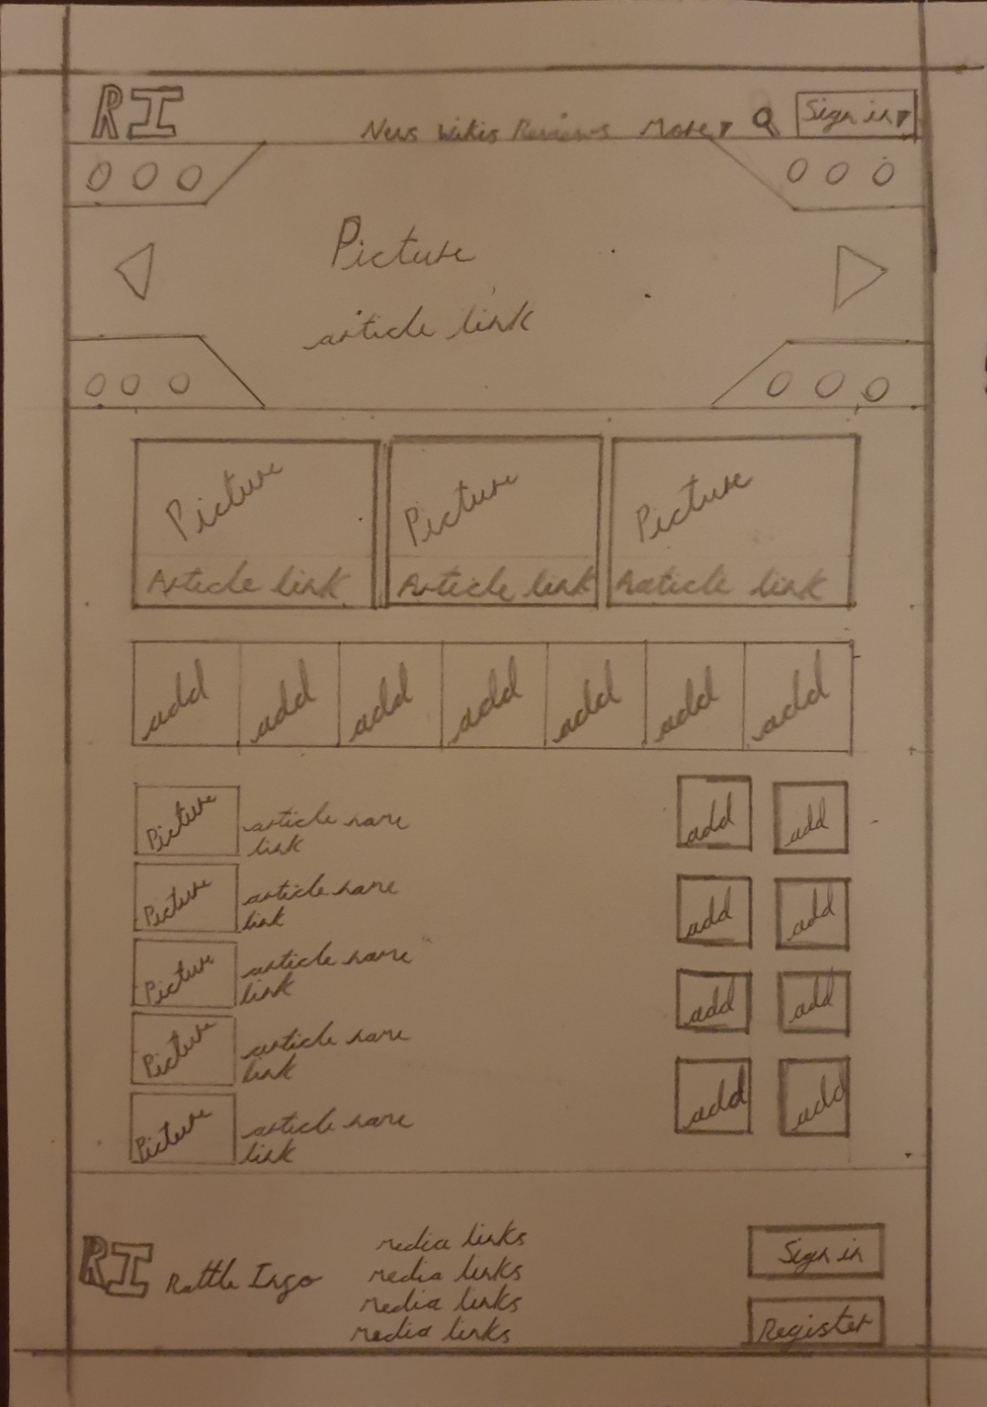
Navigation
When making the home page to my website I drew inspiration from IGN’s home page, I wanted to keep the simplistic aspect of the design however I added some new features like, adding arrows to the main article section so users can click through various main articles each with their own artistic backgrounds, I also added a section of adds and I added adds down the right side of the page. Finally I added a standard footer to the page with the logo and name of the site that I came up with (RI- Rattle Info). I took care to keep to the simplistic style I liked in IGN’s site, however I wanted to make navigation as simple as possible for users, IGN has 2 navbars, one at the top right of the page and one lover down, to simplify this I only kept the top navbar and added another section to the nav bar (more), this section has a drop down arrow and once clicked it reveals the options from the second nav bar that I removed, this way I can make navigation easier and simplified without loosing any of the functionality.
Home page mobile
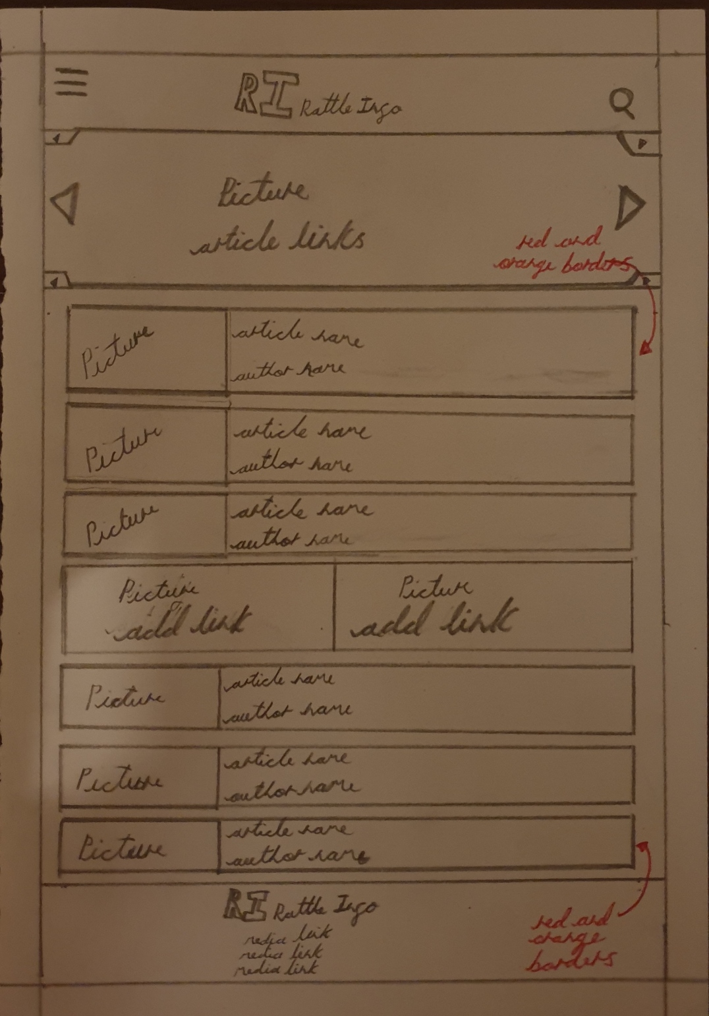
Navigation
When making the mobile version of my home page I realized that I had to simplify my design even further as I had less screen real estate. I decide to maker the nav bar a drop down menu as that’s the most common way of adding a var bar on mobile, I also moved it to the left and moved the logo to the middle. I decided to keep the main articles section as that is the most exciting feature of my homepage, however I made it smaller and simplified it by adding arrows to indicate that users can swipe left or right to see other main articles. I had to remove a lot of the adds due to the lack of space so I added a section in the middle of the page with 2 huge adds, this way there are less adds however the 2 adds are more noticeable, it was a compromise but it worked out in the end.
I kept the same colour scheme for the most part however I drew inspiration from The Verge by surrounding the articles with red and orange borders. (Example)
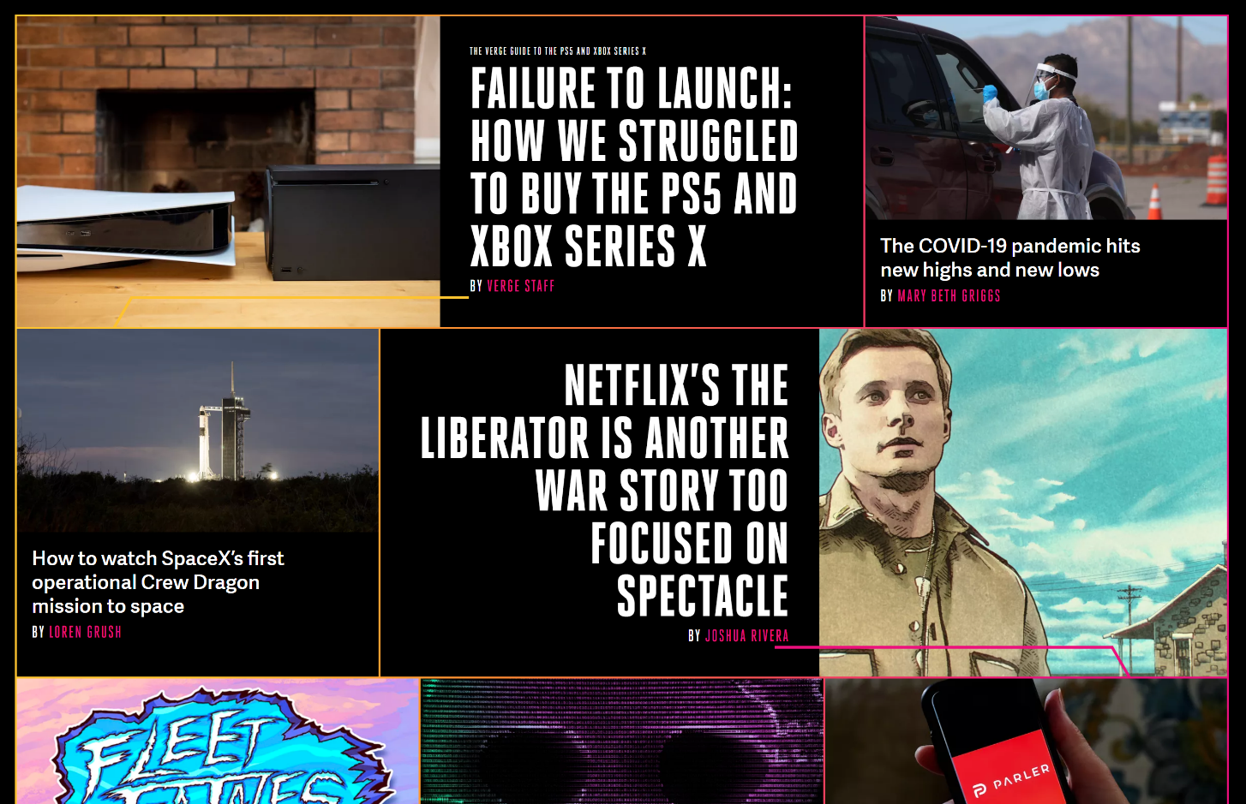

Article page desktop
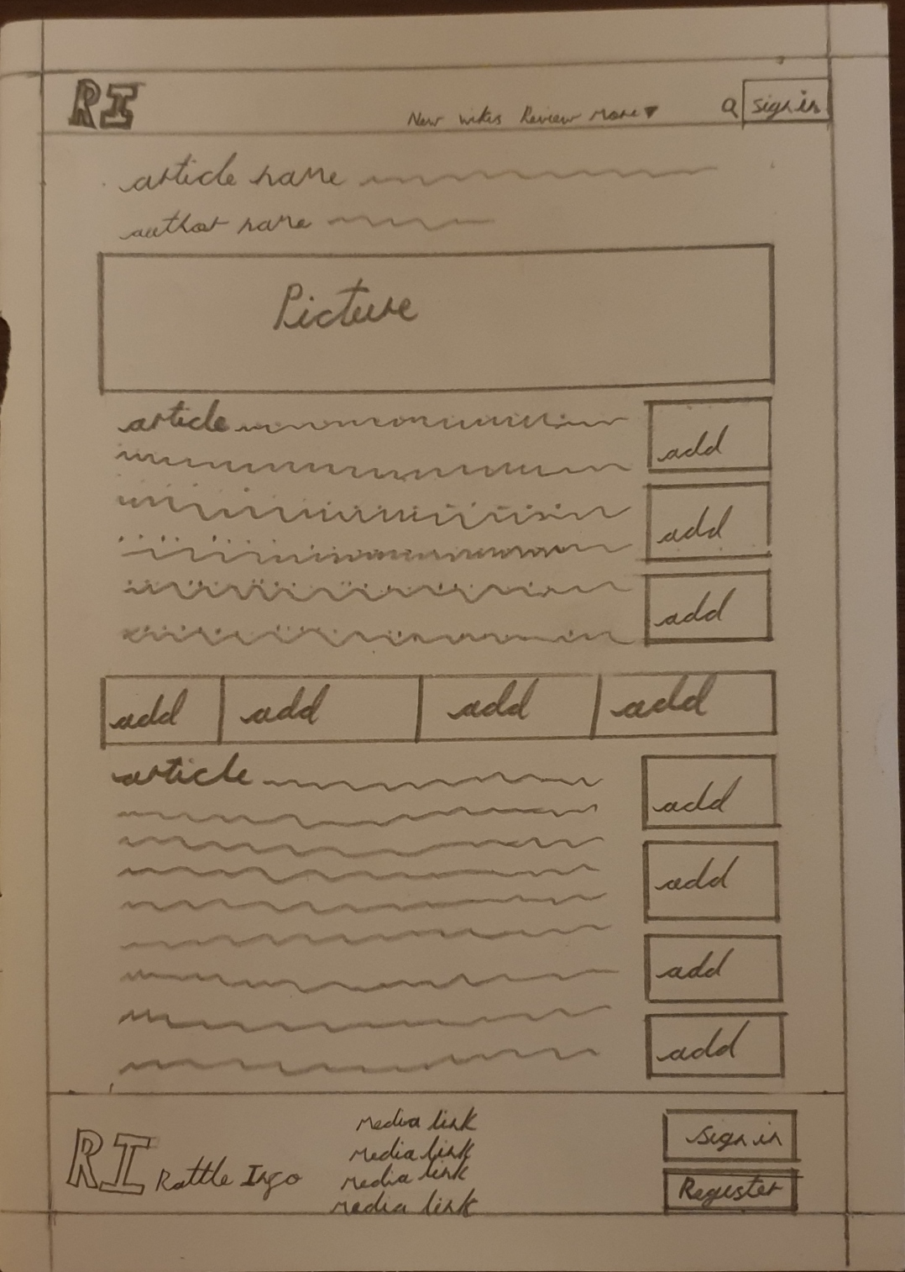
Navigation
When designing the layout of my article page I realized that most article pages on news sites are the same. Most of the articles I found online start with the name of the article, the name of the author, a large picture of the article and then the content of the article. I designed my article page much the same way however I added an add section half way down the article to break up the page making it more visually appealing, I also added adds down the right side of the page. I kept the nav bar the same for my article page and also kept the footer more or less the same.
I kept the colour scheme consistent too, dark grey and white with red accents. (Example)
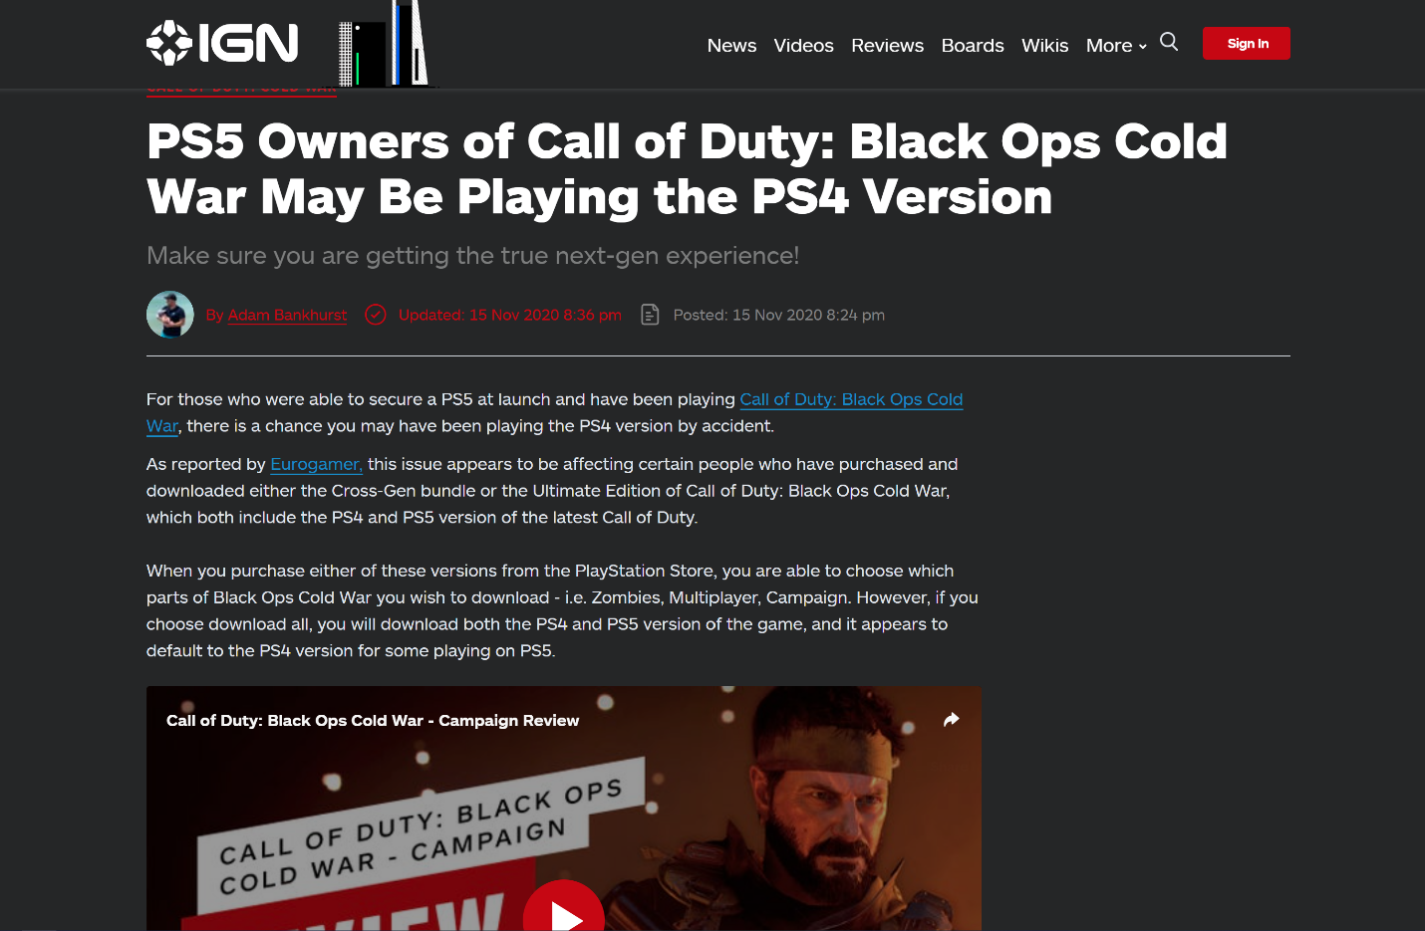

Article page mobile
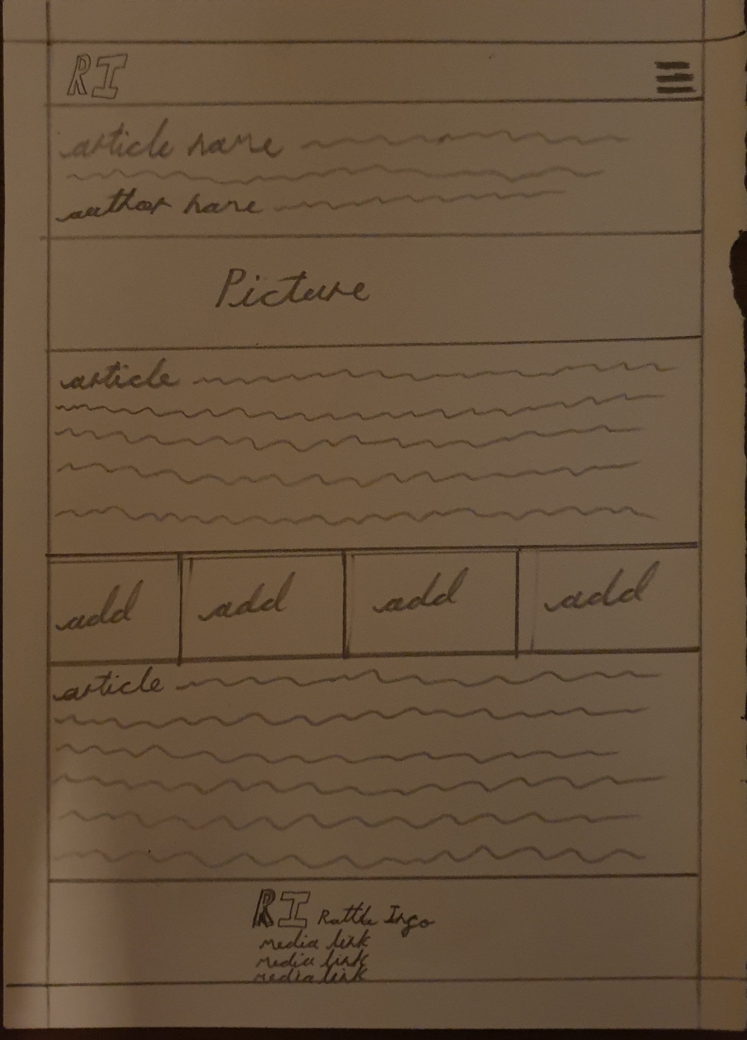
Navigation
When making the mobile version of my article page I realized that I could keep my design more or less the same. The only things I had to change were the nav bar, the footer and the adds. While the main layout of the page stayed the same I removed the adds down the right side of the page as there wasn’t any space for them. I also made the nav bar a drop down to save space, and lastly I changed the footer to make it mobile friendly with the logo and some media links under it.

